Sreeti Ravi

Working with JSON, Arrays, and Structs in BigQuery

1. Create a new dataset to store the tables

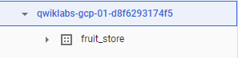

1. Practice working with Arrays in SQL

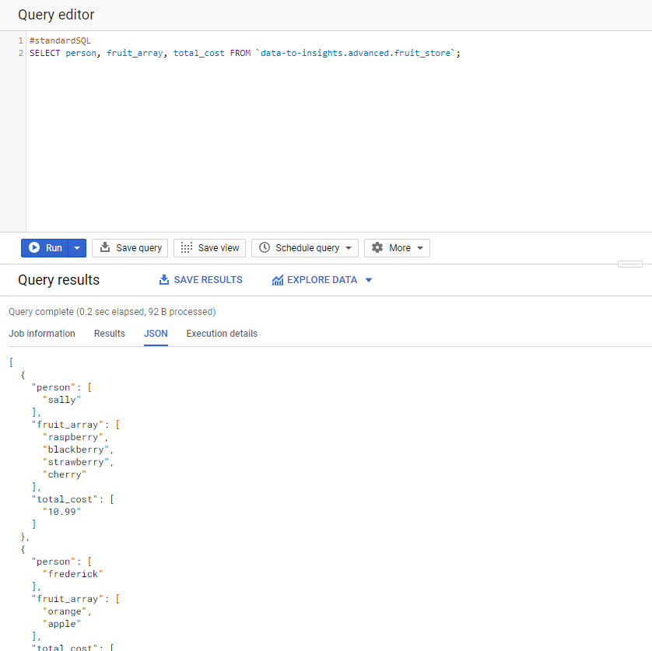

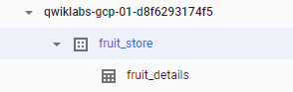

1. Creating your own arrays with ARRAY_AGG()

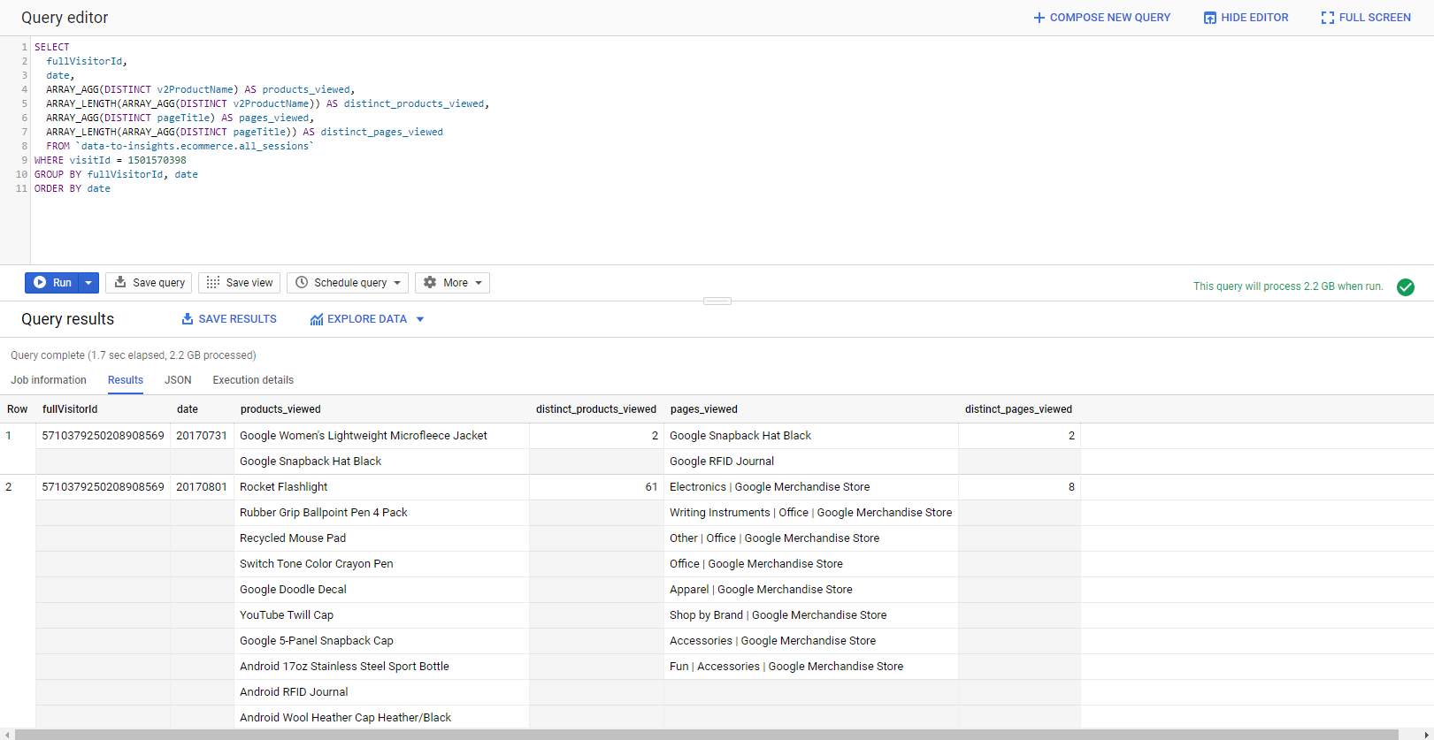

1. Querying datasets that already have ARRAYs

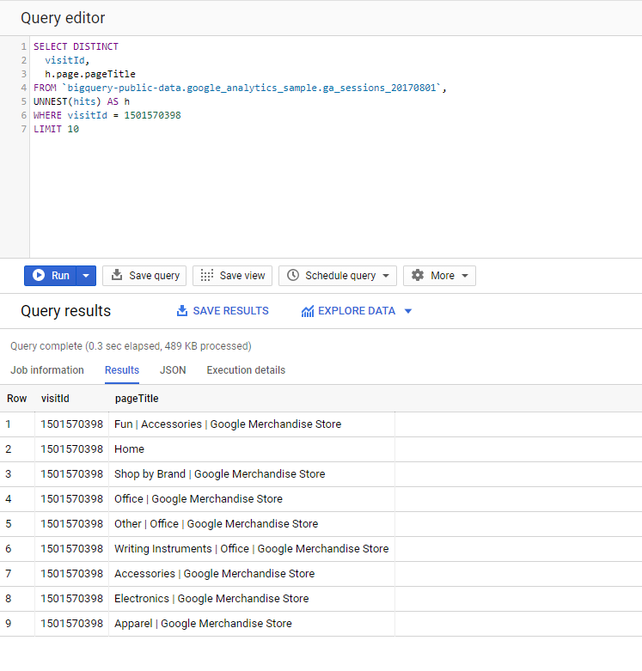

1. Introduction to STRUCTs

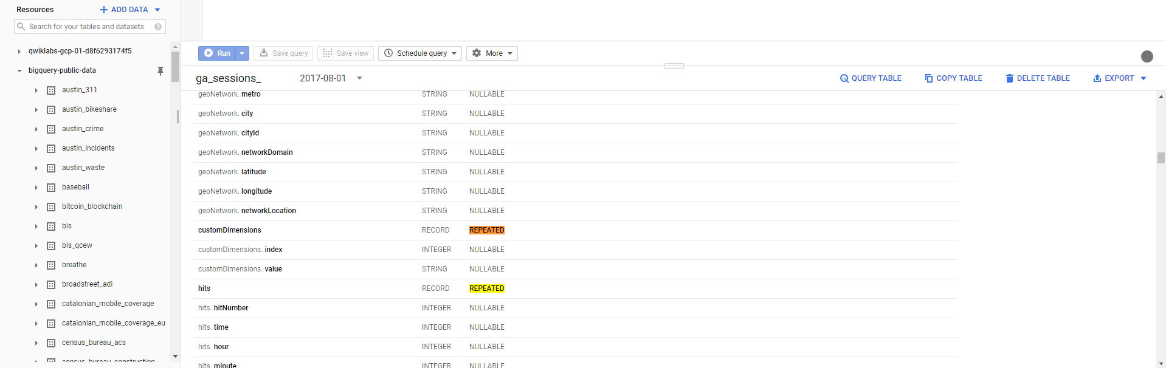

1. Practice with STRUCTs and ARRAYs

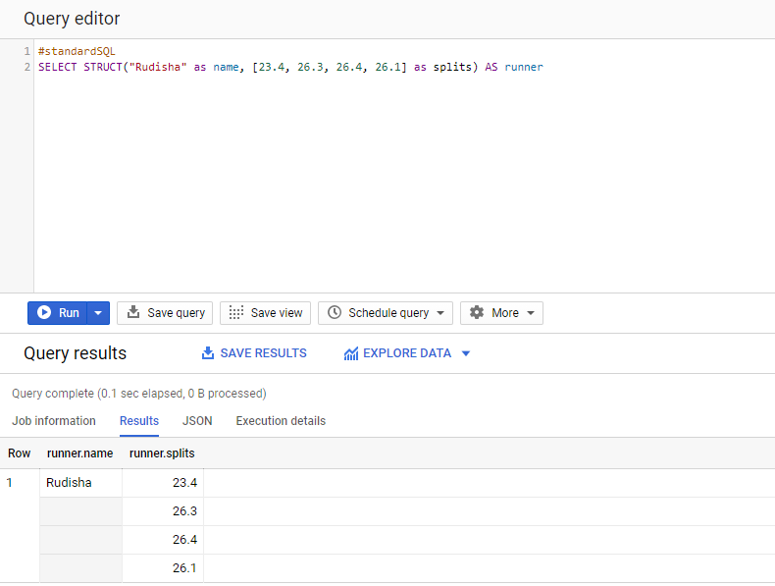

1. Practice ingesting JSON data

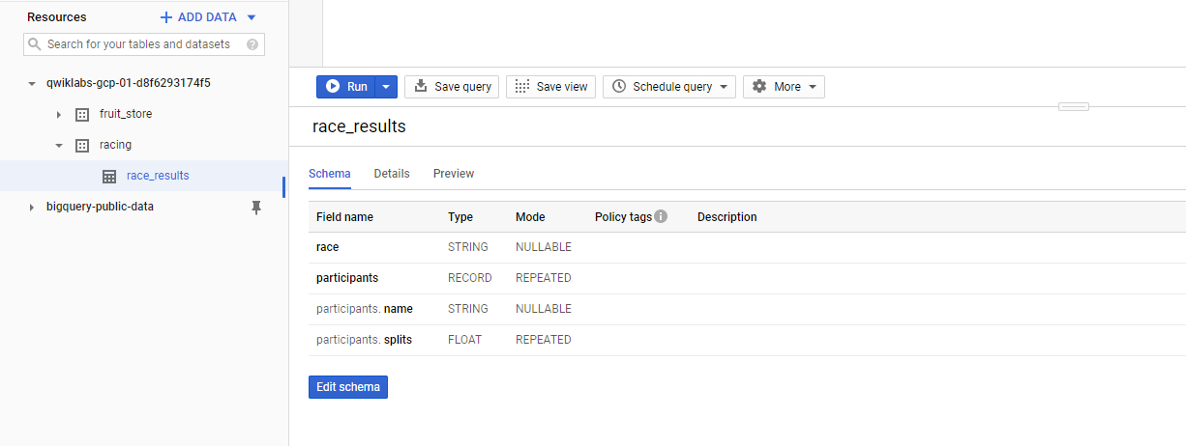

1. Lab Question: STRUCT()

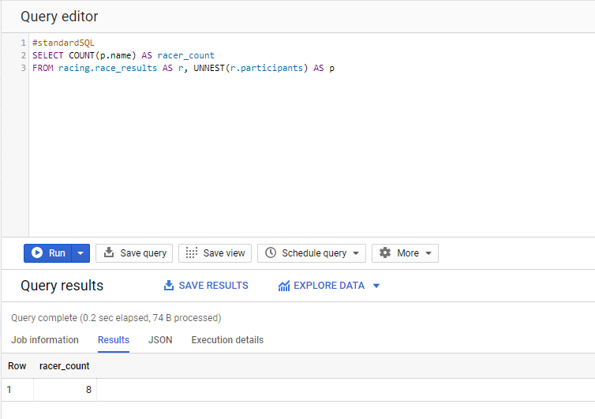

1. Lab Question: Unpacking ARRAYs with UNNEST()

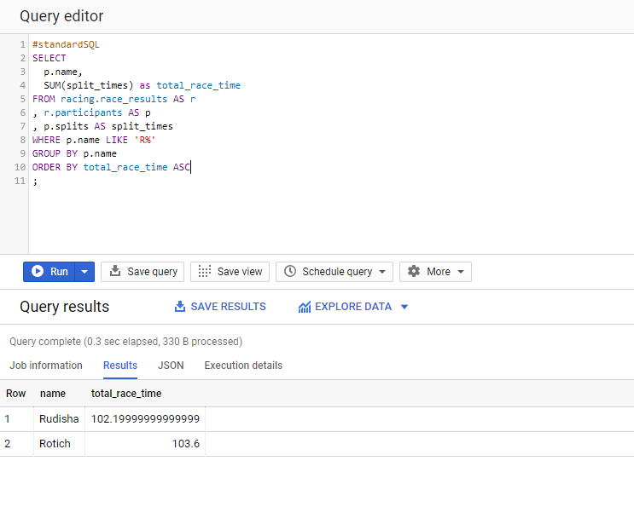

1. Filtering within ARRAY values

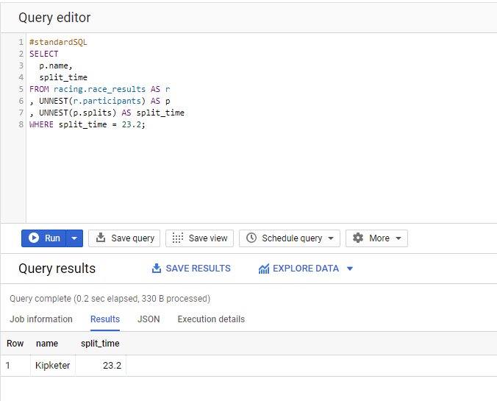

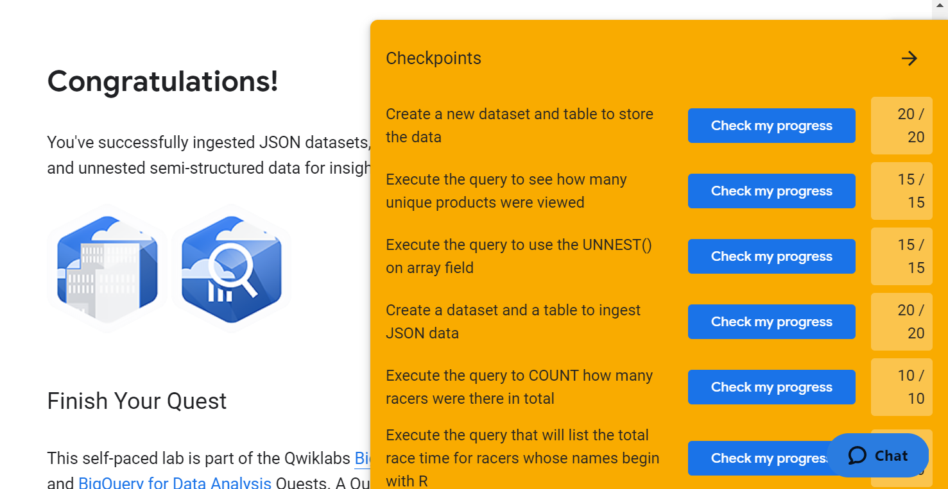

UNNEST() changes elements in an array back into rows. It takes an array and returns a tables with a single row for each element in the array. If the array consists of structs it conveniently turns them into columns. UNNEST is used in the from clause. It can be useful to flatten an array and see the items in the array. It can be used to collect items from one array to use in another query.

I have worked with semi-structured data at work before and have some experience, but I learned some new query tools that will be helpful in the future. This was my first time using BigQuery and I thought this was a good introduction to it. I thought it was easy to use and for a first-time user, all the features are easy to find.